Terchova
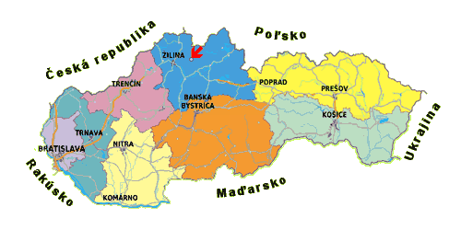
As soon as we passed through Zilina I knew we were going to a special place. It was similar to driving in and out of a flash rain when there’s suddenly a clear line on the road dividing the place were it has rained and the place were it has not… suddenly everything seemed brighter and fresher and greener and extra alive. When I was younger I had two very vivid reoccurring dreams involving a river and a mountain, and there were a few times in Terchova where I actually experienced the peculiar sensation of walking into a world you’ve previously only dreamt
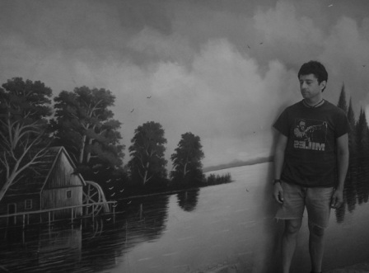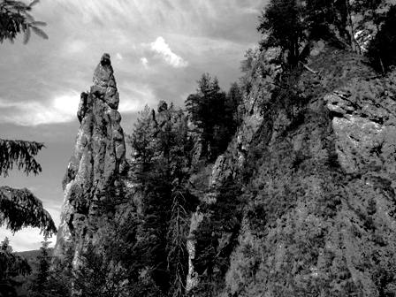
We stayed at the Privat Lucka in Vysne Kamence, and because we were still a little early in the season we were lucky enough to have the whole place to ourselves (it’s usually booked full with three parties per floor sharing kitchens and common grounds), and for the first hike we simply walked off into the backyard and up through the crystal-clear brooks at the mountain foothill trails
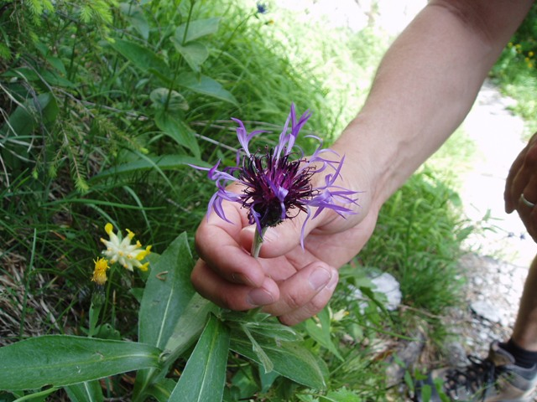
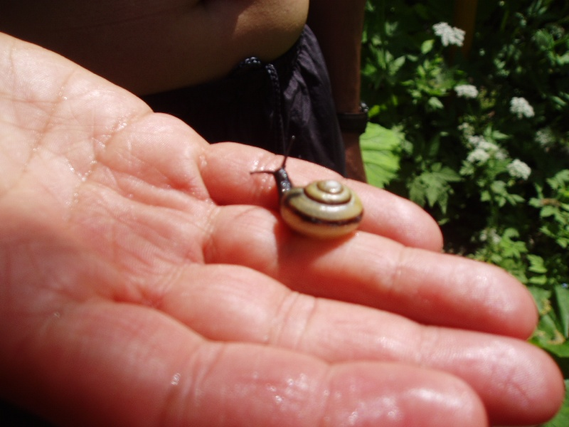
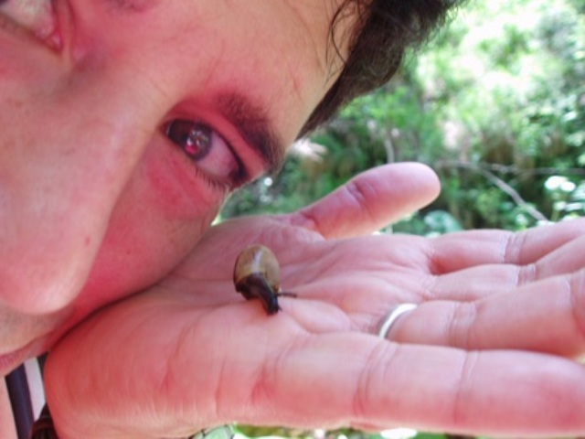
The Obsivanka and Tiesnavy trails were one of the most beautiful hikes I’ve ever been on
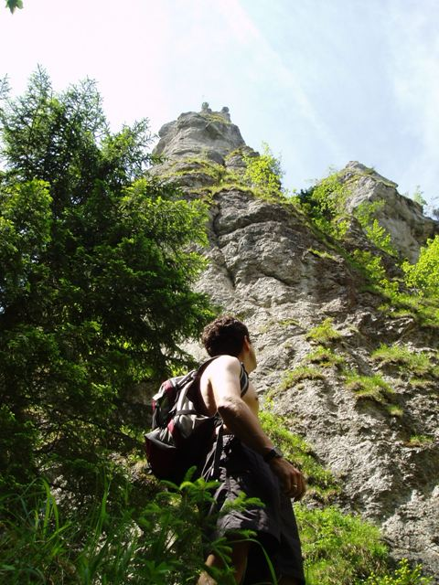
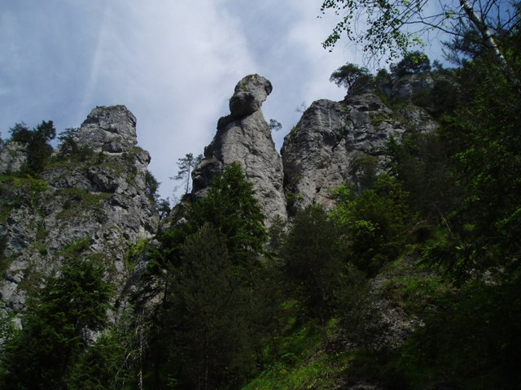
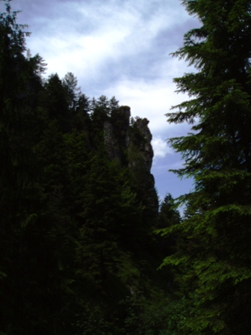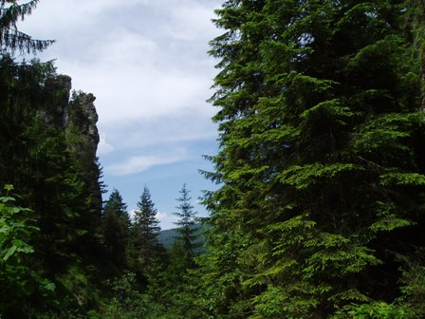
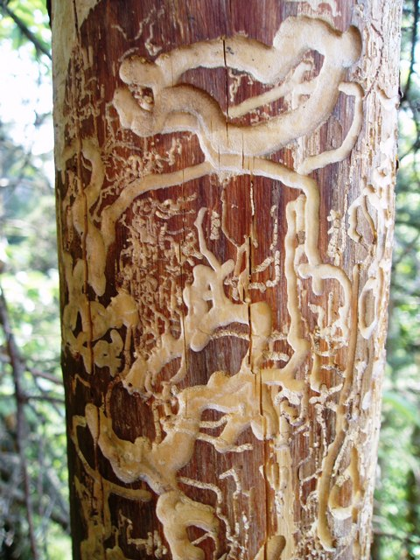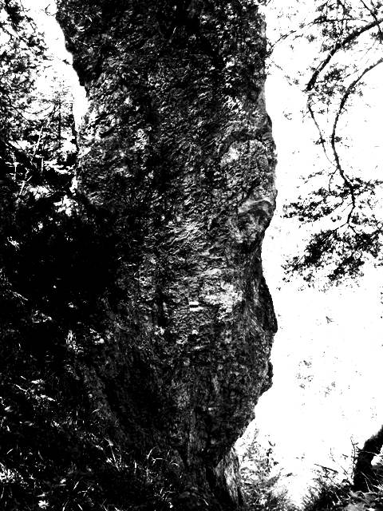
but we were somewhat under prepared for its seven hours of steep rock valleys and occasionally alarmingly narrow cliff side passages—bringing only a bottle of mineral water, two bananas and a couple of long sleeve shirts
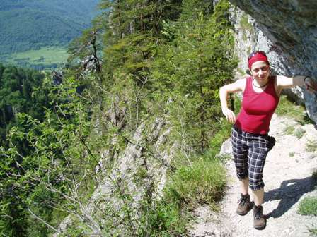
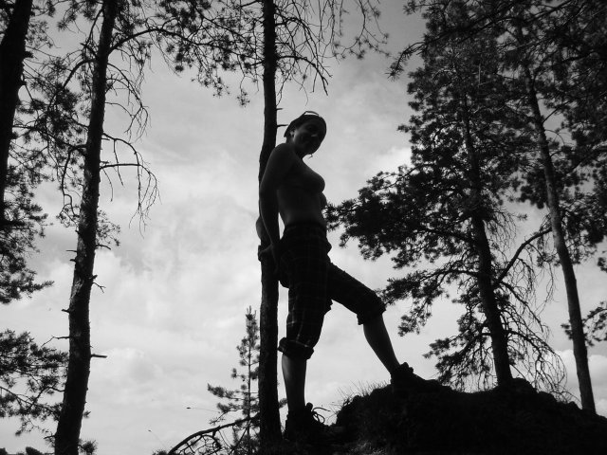
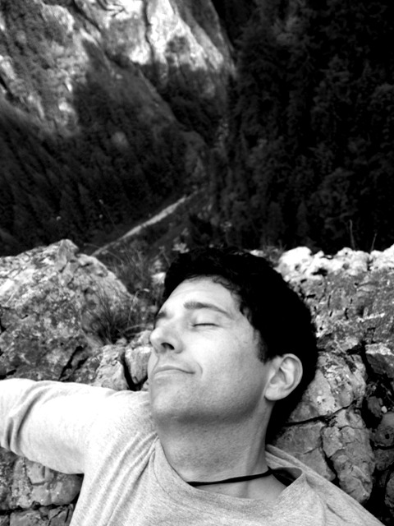
But reoccurring archetypal dreams are the province of innocence, at least in their purest and most direct form, and while I wish we’d packed a lunch and perhaps a tea or two, I was happy to have made it without them and to have been busy and in love enough not to have cared
